Name : Vũ Đức Tùng
IRN: 2331300132
Course : CSE 301
Lab 2
Problem 1:
- Entities and attributes:
- customer: customer_id, full_name, address, phone_number, birthday, registration_date, sale_amount
- staff: staff_id, full_name, hire_date, phone_number
- product: product_id, product_name, unit, country, selling_price
- invoice: invoice_id, invoice_date,
- invoice_detail:quantity, selling_price
- Relation:
- customer - invoice : pay (1 : n)
- invoice – invoice_details : contains ( 1 : n)
- staff – invoice : create (1:n)
- product – invoice : have ( m:n)
- Weak entity:
- Invoice_details
- ERD
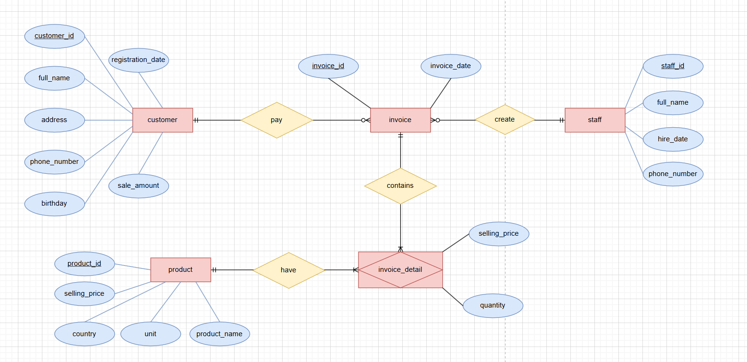

- Relational model :
- customer
Column | Datatype | Description
customer_id | CHAR(5) | Fix length 5 characters, Primary key
full_name | VARCHAR(50) | Max length 50 characters, NOT NULL
address | VARCHAR(255) | Max length 255 characters
phone_number | VARCHAR(14) | Max length 14 characters, UNIQUE
date_of_birth | DATE
registration_date | DATE
total_sales_amount | INT | >=0

- staff
Column | Datatype | Description
staff_id | CHAR(10) | Primary key
full_name | VARCHAR(30) | Max length 100 characters, NOT NULL
hire_date | DATE | NOT NULL
phone_number | VARCHAR(14) | Max length 15 characters
- product
Column | Datatype | Description
product_id | INT | Primary key
product_name | VARCHAR(100) | Max length 100 characters, NOT NULL
unit | VARCHAR(20) | Max length 20 characters
country_of_origin | VARCHAR(50) | Max length 50 characters
selling_price | DECIMAL(10,2) | NOT NULL, >= 0

- invoice
Column | Datatype | Description
invoice_id | CHAR(5) | Primary key
invoice_date | DATETIME | NOT NULL
staff_id | CHAR(10) | Foreign key references staff(staff_id), NOT NULL
customer_id | CHAR(5) | Foreign key references customer(customer_id),

- invoice_detail
Column | Datatype | Description
invoice_id | INT | Primary key, Foreign key references invoice(invoice_id)
product_id | INT | Primary key, Foreign key references product(product_id)
quantity | INT | NOT NULL, > 0
selling_price | DECIMAL(10,2) | Reflects price at transaction time, NOT NULL

- MySQL
CREATE DATABASE IF NOT EXISTS sales_management;

USE sales_management;

CREATE TABLE customer(
customer_ID CHAR(5) PRIMARY KEY,
full_name VARCHAR(50),
address VARCHAR(255),
phone_number VARCHAR(14) UNIQUE,
date_of_birth DATE,
registration_date DATE,
total_sales_amount DECIMAL(15, 2) DEFAULT 0.00
);
CREATE TABLE staff (
staff_id CHAR(10) PRIMARY KEY,
full_name VARCHAR(30) NOT NULL,
hire_date DATE NOT NULL,
phone_number VARCHAR(14)
);
CREATE TABLE product (
product_id INT PRIMARY KEY,
product_name VARCHAR(100) NOT NULL,
unit VARCHAR(20),
country_of_origin VARCHAR(50),
selling_price DECIMAL(10, 2) NOT NULL
);
CREATE TABLE invoice (
invoice_id INT PRIMARY KEY,
invoice_date DATETIME NOT NULL,
staff_id CHAR(10) NOT NULL,
customer_id CHAR(5) NULL,
FOREIGN KEY (staff_id) REFERENCES staff(staff_id),
FOREIGN KEY (customer_id) REFERENCES customer(customer_ID)
);
CREATE TABLE invoice_detail (
invoice_id INT,
product_id INT,
quantity INT NOT NULL,
selling_price DECIMAL(10, 2) NOT NULL,
PRIMARY KEY (invoice_id, product_id),
FOREIGN KEY (invoice_id) REFERENCES invoice(invoice_id),
FOREIGN KEY (product_id) REFERENCES product(product_id)
);

SHOW TABLES;
Problem 2:
- Entities and attributes:
- employee: employee_id, first_name, last_name, date_of_birth, gender, address, supervisor_id, dept_id
- department: dept_id, dept_name, manager_id, manager_start_date
- dept_location: dept_id, location
- project: project_id, project_name, project_location, dept_id
- works_on: employee_id, project_id, hours_per_week
- dependent: employee_id, dependent_name, date_of_birth, gender, relationship
- full_time_employee: employee_id, monthly_salary
- part_time_employee: employee_id, hourly_rate
- Relation:
- employee - department: works_for (N : 1)
- employee - employee: supervises (1 : N, recursive)
- department - employee: managed_by (1 : 1)
- department - dept_location: has (1 : N)
- project - department: controlled_by (N : 1)
- employee - project: works_on (M : N), attribute: hours_per_week
- employee - dependent: has (1 : N)
- Weak entity:
- Dependent (weak entity; identifying entity: Employee; identifying relationship: has)
- DepartmentLocation (weak entity; identifying entity: Department; identifying relationship: has)
- ERD
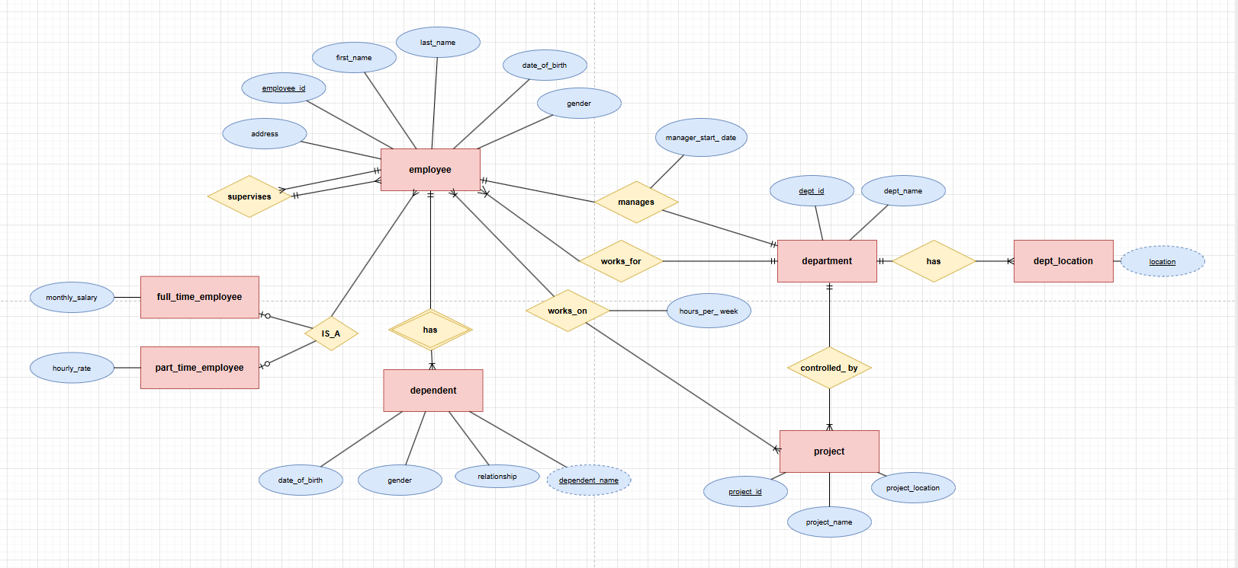
- Relational model:
- employee
Column | Datatype | Description
employee_id | INT | Primary key
first_name | VARCHAR(50) | NOT NULL
last_name | VARCHAR(50) | NOT NULL
date_of_birth | DATE
gender | ENUM('M','F')
address | VARCHAR(255)
supervisor_id | INT | Foreign key references employee(employee_id), nullable
dept_id | INT | Foreign key references department(dept_id), NOT NULL

- department
Column | Datatype | Description
dept_id | INT | Primary key
dept_name | VARCHAR(100) | NOT NULL, UNIQUE
manager_id | INT | Foreign key references employee(employee_id)
manager_start_date | DATE

- dept_location
Column | Datatype | Description
dept_id | INT | Primary key, Foreign key references department(dept_id)
location | VARCHAR(100) | Primary key

- project
Column | Datatype | Description
project_id | INT | Primary key
project_name | VARCHAR(100) | NOT NULL
project_location | VARCHAR(100)
dept_id | INT | Foreign key references department(dept_id), NOT NULL

- works_on
Column | Datatype | Description
employee_id | INT | Primary key, Foreign key references employee(employee_id)
project_id | INT | Primary key, Foreign key references project(project_id)
hours_per_week | DECIMAL(4,1) | NOT NULL, >= 0

- dependent
Column | Datatype | Description
employee_id | INT | Primary key, Foreign key references employee(employee_id)
dependent_name | VARCHAR(100) | Primary key
date_of_birth | DATE
gender | ENUM('M','F')
relationship | VARCHAR(50)

- full_time_employee
Column | Datatype | Description
employee_id | INT | Primary key, Foreign key references employee(employee_id)
monthly_salary | DECIMAL(12,2) | NOT NULL, >= 0

- part_time_employee
Column | Datatype | Description
employee_id | INT | Primary key, Foreign key references employee(employee_id)
hourly_rate | DECIMAL(8,2) | NOT NULL, >= 0

- MySQL
CREATE DATABASE IF NOT EXISTS employee_management;
USE employee_management;
CREATE TABLE department (
dept_id INT PRIMARY KEY,
dept_name VARCHAR(100) NOT NULL UNIQUE,
manager_id INT,
manager_start_date DATE
);
CREATE TABLE employee (
employee_id INT PRIMARY KEY,
first_name VARCHAR(50) NOT NULL,
last_name VARCHAR(50) NOT NULL,
date_of_birth DATE,
gender ENUM('M', 'F'),
address VARCHAR(255),
supervisor_id INT,
dept_id INT NOT NULL,
FOREIGN KEY (supervisor_id) REFERENCES employee(employee_id),
FOREIGN KEY (dept_id) REFERENCES department(dept_id)
);
ALTER TABLE department
ADD CONSTRAINT fk_dept_manager
FOREIGN KEY (manager_id) REFERENCES employee(employee_id);

CREATE TABLE dept_location (
dept_id INT,
location VARCHAR(100),
PRIMARY KEY (dept_id, location),
FOREIGN KEY (dept_id) REFERENCES department(dept_id)
);
CREATE TABLE project (
project_id INT PRIMARY KEY,
project_name VARCHAR(100) NOT NULL,
project_location VARCHAR(100),
dept_id INT NOT NULL,
FOREIGN KEY (dept_id) REFERENCES department(dept_id)
);
CREATE TABLE works_on (
employee_id INT,
project_id INT,
hours_per_week DECIMAL(4,1) NOT NULL CHECK (hours_per_week >= 0),
PRIMARY KEY (employee_id, project_id),
FOREIGN KEY (employee_id) REFERENCES employee(employee_id),
FOREIGN KEY (project_id) REFERENCES project(project_id)
);
CREATE TABLE dependent (
employee_id INT,
dependent_name VARCHAR(100),
date_of_birth DATE,
gender ENUM('M', 'F'),
relationship VARCHAR(50),
PRIMARY KEY (employee_id, dependent_name),
FOREIGN KEY (employee_id) REFERENCES employee(employee_id)
);
CREATE TABLE full_time_employee (
employee_id INT PRIMARY KEY,
monthly_salary DECIMAL(12,2) NOT NULL CHECK (monthly_salary >= 0),
FOREIGN KEY (employee_id) REFERENCES employee(employee_id)
);
CREATE TABLE part_time_employee (
employee_id INT PRIMARY KEY,
hourly_rate DECIMAL(8,2) NOT NULL CHECK (hourly_rate >= 0),
FOREIGN KEY (employee_id) REFERENCES employee(employee_id)
);

SHOW TABLES;

